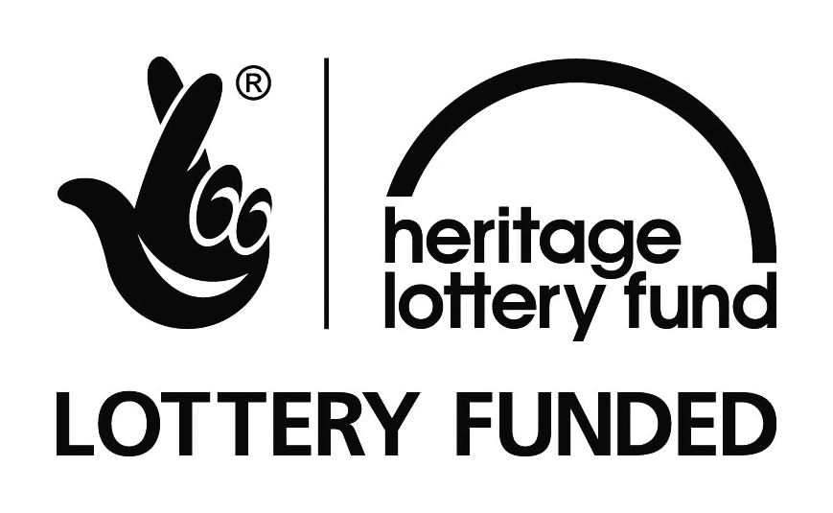

THE EFFIGY RESTORATION PROJECT HAS ONLY BEEN MADE POSSIBLE DUE TO CONTRIBUTIONS FROM THOSE LISTED BELOW.
Heritage Lottery Fund (Sharing Heritage)
Church Buildings Council
Francis Coales Charitable Foundation
Barbara Whatmore Charitable Trust
St Andrews Trust
Garfield Weston Foundation
Allchurches Trust Ltd
Private Donations

